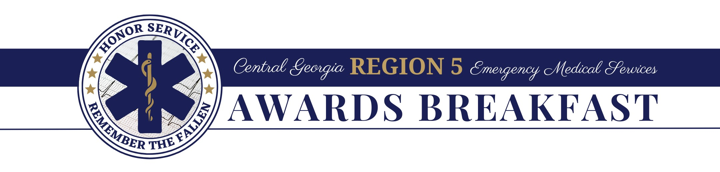
NOMINATION CATEGORIES (Select One)
NOMINATION FORM:

Service of the Year
Provider of the Year
Director of the Year
Educator of the Year
Rising Star Award
David Moore Award of Excellence
Medal of Valor

* See Nomination Criteria for details

Nominee Information (Person being nominated)
Name:
Title:
Agency Name:
Cell Phone: |  | Alt Phone:
Email Address:

Nominator Information (Nominations can be anonymous.)
Name:
Title:
Agency Name:
Cell Phone: |  | Alt Phone:
Email Address:
Today’s Date:

IMPORTANT
Please email your Nomination Form, Nomination Letter, and any supporting documentation to michelle.archer@dph.ga.gov. Email Subject Line: Awards Nomination Submission (Agency/Nominee Name)

NOMINATION CHECKLIST:
Nomination Form
Nomination Letter
Any Supporting Documentation

SERVICE OF THE YEAR
NOMINATION CRITERIA:

ELIGIBILITY: The service must hold a current Georgia Department of Public Health, Ambulance Service License and have a location/station in Region 5. The service nominated may function at the BLS or ALS level. Attach supporting documentation.

CRITERIA: The purpose of the Region 5 Emergency Medical Service of the Year Award is to provide recognition and appreciation to an EMS agency in our Region who exemplifies outstanding professionalism and service to the community. Outstanding professionalism and service is defined as going above and beyond the call of duty, whether in the direct delivery of patient care or in programs offered to the community. Consideration should be given to the question, “What services are provided by this EMS agency that sets them apart from all others?” When answering the question, consider: any specialized equipment the service may utilize (above the State required minimum), the agencies protocols and medical direction, research the agency may be involved in, and the agencies participation in local, regional, state and national activities and responses. The recognition provided by this award is not for just doing the job, but for far exceeding that which is required and expected by the community.

PROVIDER OF THE YEAR

ELIGIBILITY: The provider must hold a current Georgia EMT, EMT-I, AEMT, CT, Paramedic or RN license. The nominee must work or volunteer in Region 5 and provide direct patient care. This award is NOT open to EMS Administrators, Directors, or Supervisors who do not routinely deliver direct patient care as a primary responder.

CRITERIA: The purpose of the Region 5 Emergency Medical Service Provider of the Year is to provide recognition and appreciation to an EMS provider in our Region. The nominee should demonstrate professionalism, admirable character, high morals, and tremendous dedication to the community they serve. This provider should be described as going above and beyond the call of duty, whether in the direct delivery of patient care or in programs offered to the community. These activities should demonstrate an enhancement to the standing understanding of EMS within the community. The recognition provided by this award is not for just doing the job, but for far exceeding that which is required and expected by the community.

DIRECTOR OF THE YEAR

ELIGIBILITY: The nominee must be an EMS Director, working for a licensed EMS Service in Region 5.

CRITERIA: The purpose of the Region 5 Emergency Medical Service Director of the Year is to provide recognition and appreciation to an EMS Director in Region 5. The nominee should demonstrate admirable character, high morals, and tremendous dedication to EMS at the community, regional, and/or state level. The nominee should be involved in activities that aid in the improvement, expansion and/or enhancement of EMS within the community. Examples of this activity may include: involvement and contribution to the community, awards received, EMS affiliations and activity within those affiliations, and or contribution to EMS education.
EDUCATOR OF THE YEAR
NOMINATION CRITERIA:

ELIGIBILITY: The nominee must be an active licensed EMS instructor involved in providing instruction to EMS professionals in Region 5.

CRITERIA: The purpose of the Region 5 Emergency Medical Service Educator of the Year is to provide recognition and appreciation to an EMS Educator in Region 5. The nominee should demonstrate tremendous dedication to EMS education at the community, regional, and/or state level. The recognition provided by this award is not for just doing the job, but for far exceeding that which is required and expected by the community.

RISING STAR AWARD

ELIGIBILITY: The provider must hold a current Georgia EMT, EMT-I, AEMT, CT, Paramedic or RN license. The nominee must work or volunteer in Region 5 and provide direct patient care. All nominees for the Rising Star Award must be currently licensed in EMS with less than five (5) years field experience at their current level. This award is NOT open to EMS Administrators, Directors, or Supervisors who do not routinely deliver direct patient care as a primary responder.

CRITERIA: The nominee should demonstrate professionalism, admirable character, high morals, and tremendous dedication to the community they serve. This provider should be described as going above and beyond the call of duty, whether in the direct delivery of patient care or in programs offered to the community. The recognition provided by this award is not for just doing the job, but for far exceeding that which is required and expected by the community.

David Moore Award of Excellence

ELIGIBILITY: The David Moore Award of Excellence is to provide recognition and appreciation to a worthy individual who has unselfishly donated his/her time and efforts to continue the improvement of EMS in Region 5 at a local, regional, state, and or national level. The nominee should be involved in strengthening the public awareness and support of EMS.

CRITERIA FOR CONSIDERATION: Be specific in your explanation as to why you believe the nominated individual should receive the David Moore Award of Excellence. Please do not use generalizations.
Consideration should be given to the following criteria:
- Outstanding contribution to the development, implementation, and delivery of Emergency Medical Services in the State of Georgia.
- Demonstration of leadership and personal commitment to the achievement of excellence in EMS programs.
- Activities in the community or the Region which improved, expanded, or otherwise enhanced the role of Emergency Medical Services.
- Efforts or involvement in activities to strengthen public awareness and support of EMS.
MEDAL OF VALOR
NOMINATION CRITERIA:

ELIGIBILITY: The purpose of the Medal of Valor is to reward an individual or a team in the Central Georgia Region 5 EMS area who while in the line of duty, and under extreme or adverse conditions, distinguished themselves by performing an act of valor without regard to the potential risk to life and limb. (May be performed on or off duty)

CRITERIA FOR CONSIDERATION: Explain why you believe the nominated individual should receive the Medal of Valor. Be specific, do not use generalizations.

IMPORTANT
Please email your Nomination Form, Nomination Letter, and any supporting documentation to michelle.archer@dph.ga.gov. Email Subject Line: Awards Nomination Submission (Agency/Nominee Name)

NOMINATION CHECKLIST:
Nomination Form
Nomination Letter
Any Supporting Documentation (encouraged; not required) *

*Supporting documentation consists of photos, newspaper clippings, etc.

