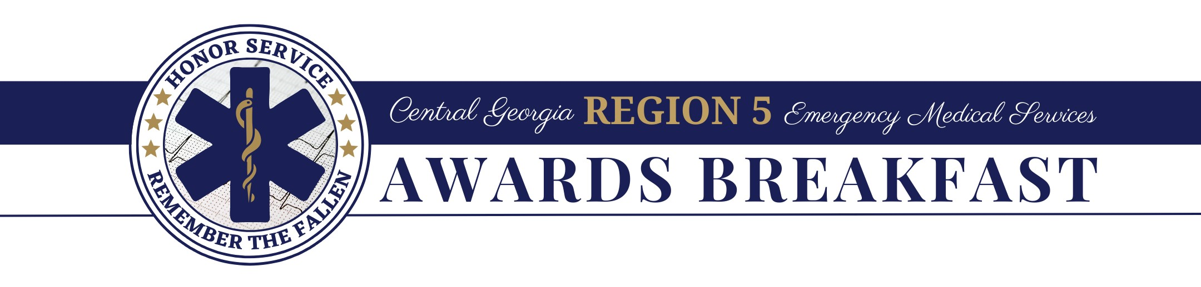
Greetings:

The Central Georgia Region 5 Emergency Medical Services (EMS) Advisory Council sponsors a banquet to honor Emergency Medical Services (EMS) professionals throughout our twenty-three (23) county Middle Georgia area. I'm sure you know the sacrifices EMS professionals are called to make, and I'm sure you appreciate what they do for their communities.

The Awards Committee presents six (6) primary awards during the Banquet. That leaves quite a few deserving professionals without significant recognition. In order to recognize and award more individuals, the Awards Committee has aggressively sought new sponsors and donations of door prizes from local and area businesses and organizations. Overall, this has proven to be very successful and is greatly appreciated by these deserving professionals.

To make the 2024 EMS Awards Banquet the best ever, the Awards Committee would be most appreciative if your organization would consider becoming a sponsor at one of the following levels:

PLATINUM SPONSOR: $1,000.00 +
GOLD SPONSOR: $500.00
SILVER SPONSOR: $250.00
DOOR PRIZE DONOR: $10.00 to $249.99

Sponsorship checks should be made payable to the Central GA Directors Association, a non-profit 501c6 organization.

Suppose you would like to participate but do not desire to be a sponsor. In that case, your business or organization can provide a door prize such as a gift card, an item of merchandise, or your business' promotional items.

Again, if your company policy permits, we would be most appreciative if you would consider becoming a sponsor or providing a door prize donation for this worthy event. If you are a sponsor or donate a door prize, the name of your business will appear in the banquet program and will be announced at least once during the Banquet. Please mail your sponsorship or door prize to the address below or call and we will arrange to have it picked up. Don't hesitate to get in touch with us if you have any questions.

The Awards Breakfast is scheduled for January 10, 2024. Thank you for ongoing partnership and support.

Sincerely,
Kristal Claxton Smith
Mail donations or door prizes to:
Region 5 EMS Awards Banquet
1000 Indian Springs Drive
Forsyth, GA 31029

Kristal Claxton Smith
478-288-0708
Region5rtac@gmail.com
Awards Committee Chairman

